**TASK : By using Session Manager Parameter Store creating our domain credentials in a parameter and get these in encryption and decryption formats.**

1. Create parameter in development level.
2. AWS Systems Manager → Parameter Store → /my-app/dev/db-url
3. 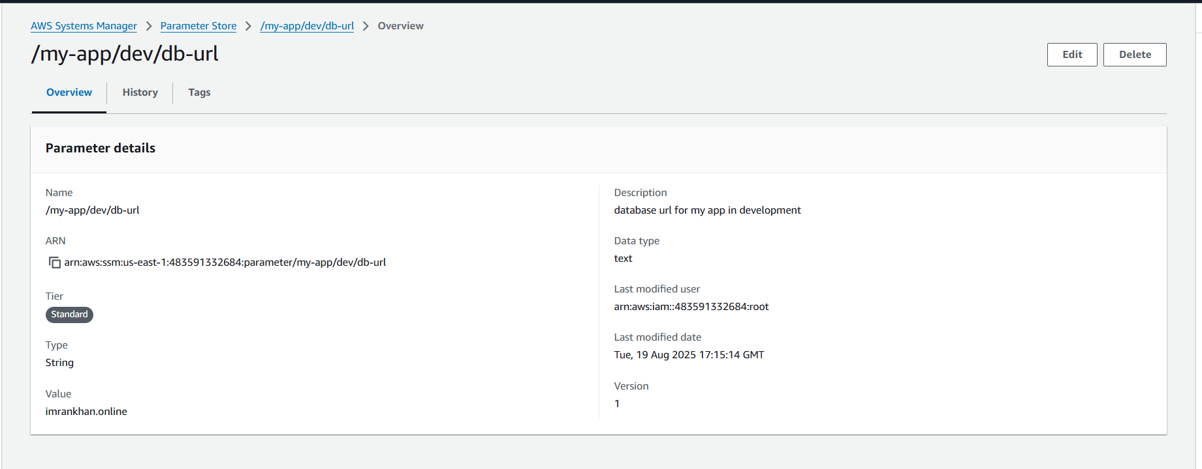
4. And create another parameter for app password
5. 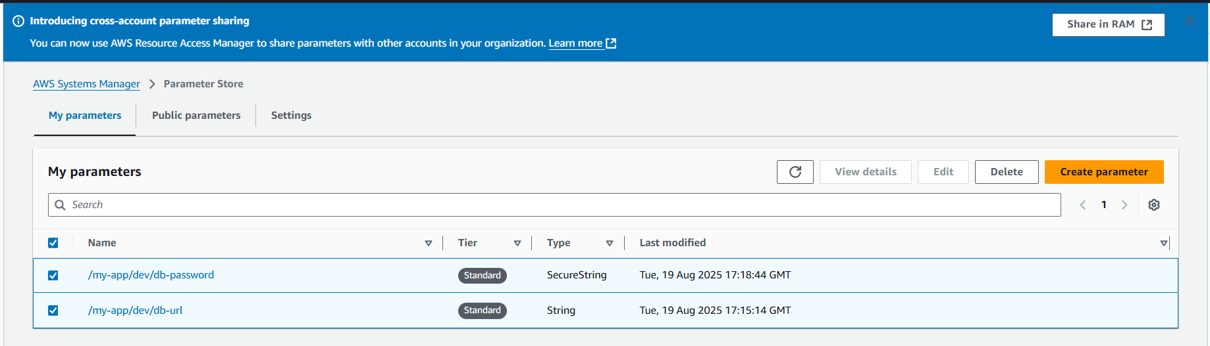
6. Creating same in production level also, So total 4 parameters created
7. 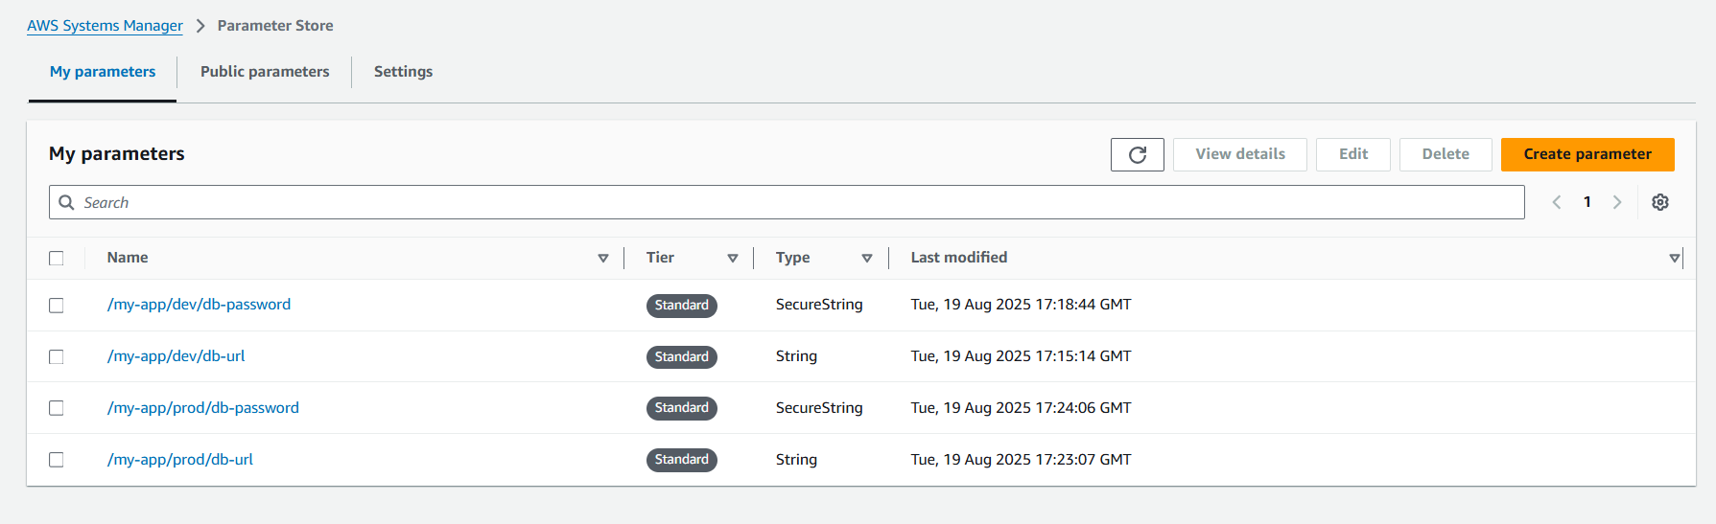
8. Open cloudshell cli or any cli and get parameters
9. aws ssm get-parameters --names /my-app/dev/db-url /my-app/dev/db-password
10. 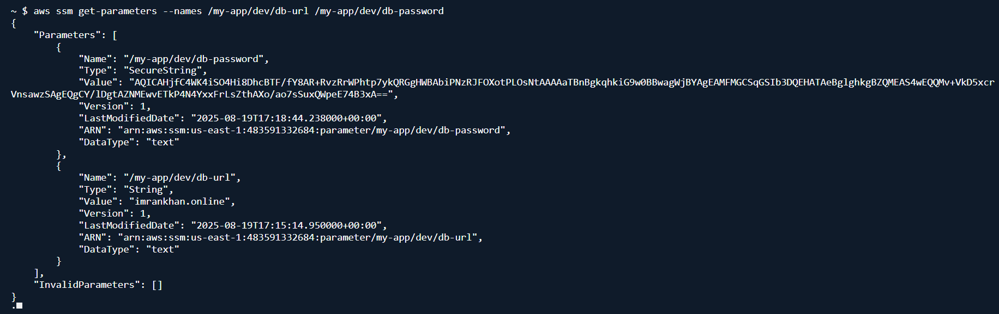
11. For string we get plain text but for secure string having password came in encrypted
12. Now try to decrypt we can get both url and password in plain text
13. aws ssm get-parameters --names /my-app/dev/db-url /my-app/dev/db-password --with-decryption
14. 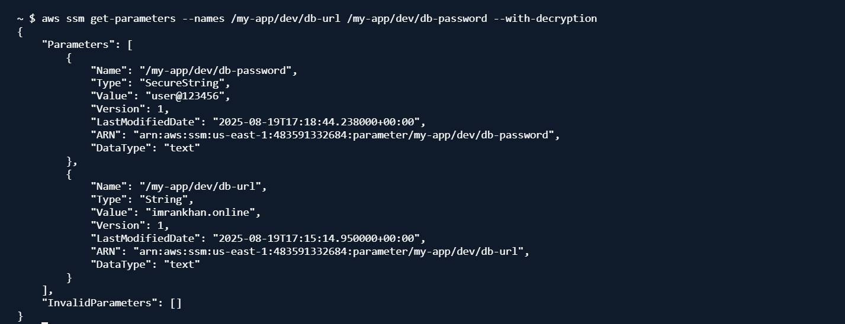
15. We can get the parameters by giving path also
16. aws ssm get-parameters-by-path --path /my-app/dev
17. 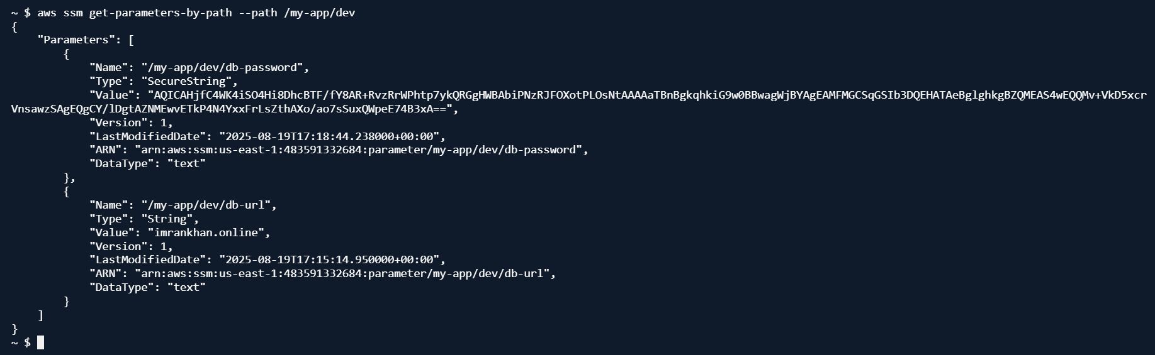
18. We can get all parameters using recursive
19. aws ssm get-parameters-by-path --path /my-app/ --recursive
20. 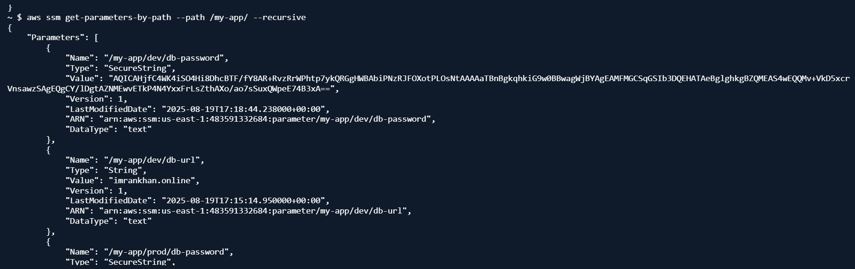
21. Now getting all parameters in plain text using recursive decryption.
22. aws ssm get-parameters-by-path --path /my-app/ --recursive --with-decryption
23. 